**Cascading Style Sheets**

1. **Form Tag**
   1. Can be applied on group of input element
   2. <form></form>
   3. Attribute - action -- “POST and GET”
   4. Requesting for the certain webpage from web server is called as GET and After validation completed then webpage again push back to server called as POST

**Input Field Properties**

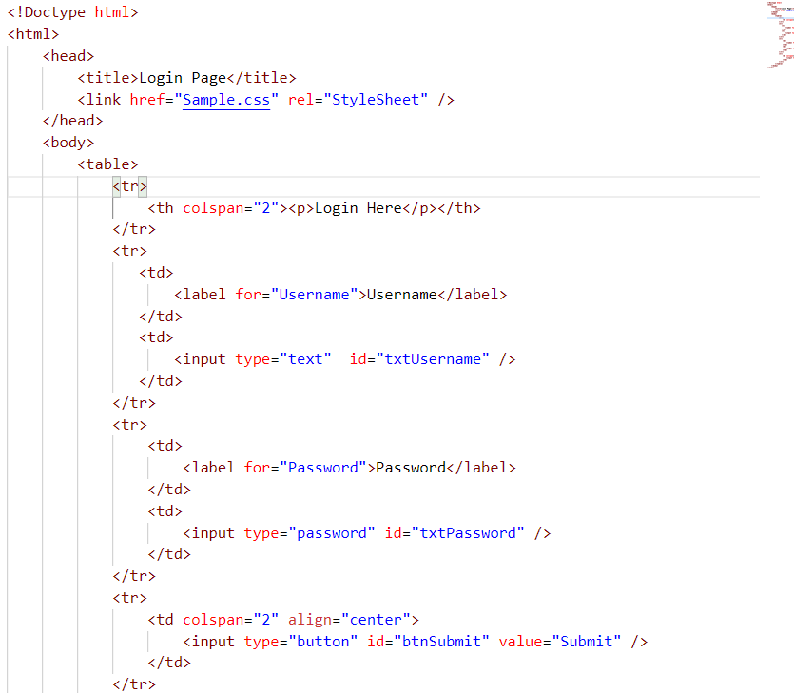

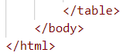

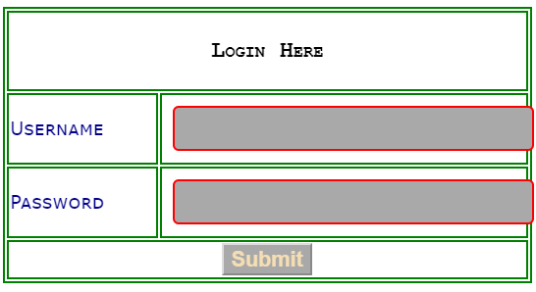

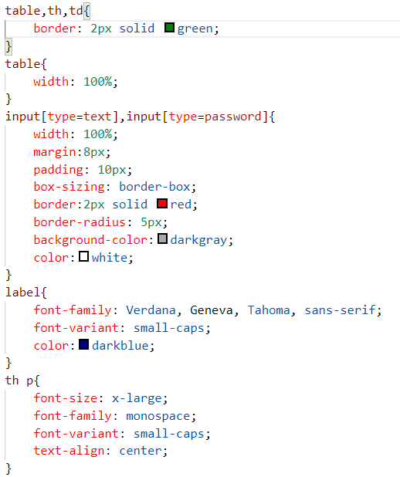

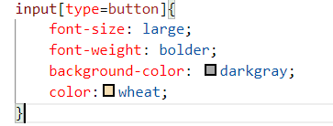

**Style of Select or Drop down list:**

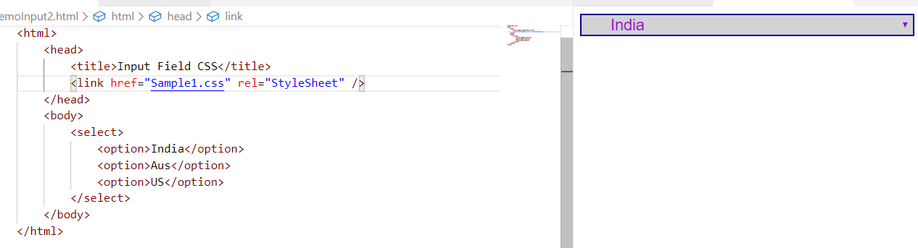

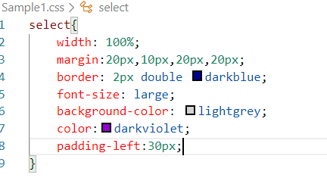

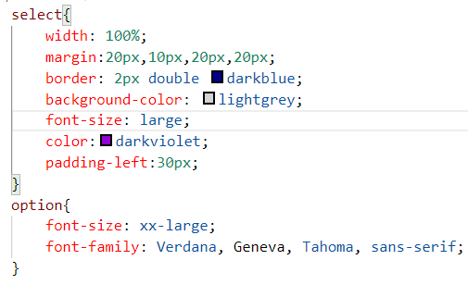

**Text Shadow and Box Shadow**

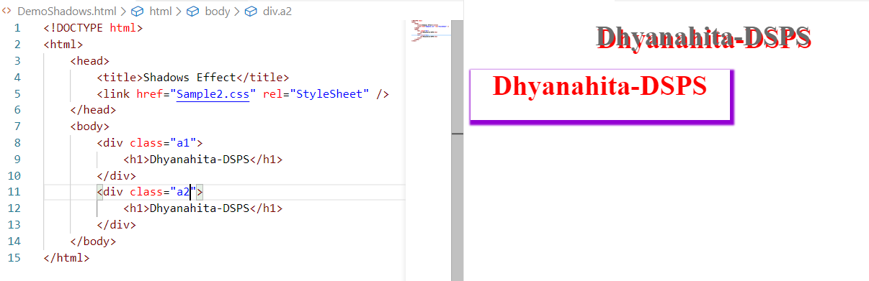

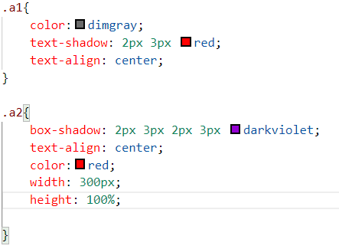

**2D Transforms : to make the position to change**

1. translate()
2. scaleX()
3. scaleY()
4. rotate()
5. scale()
6. skewX()
7. skewY()
8. skew()
9. matrix()

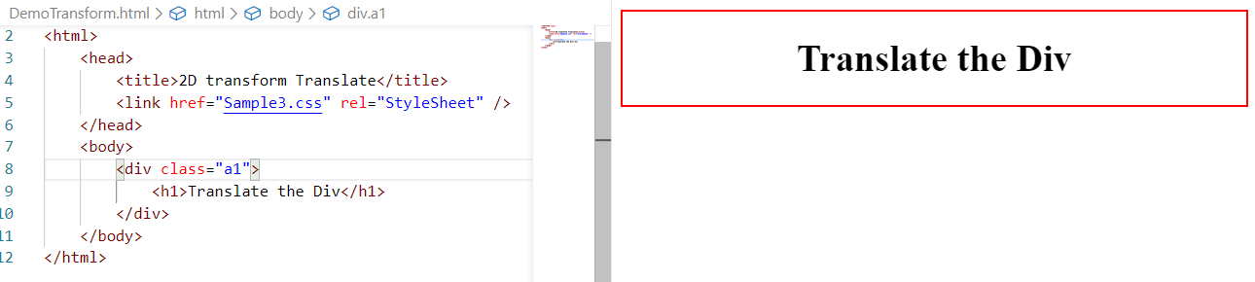

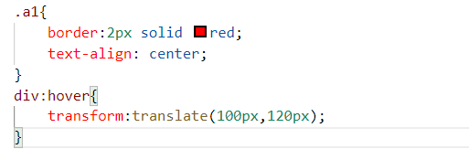

**3D Transforms:**

1. rotateX()
2. rotateY()
3. rotateZ()

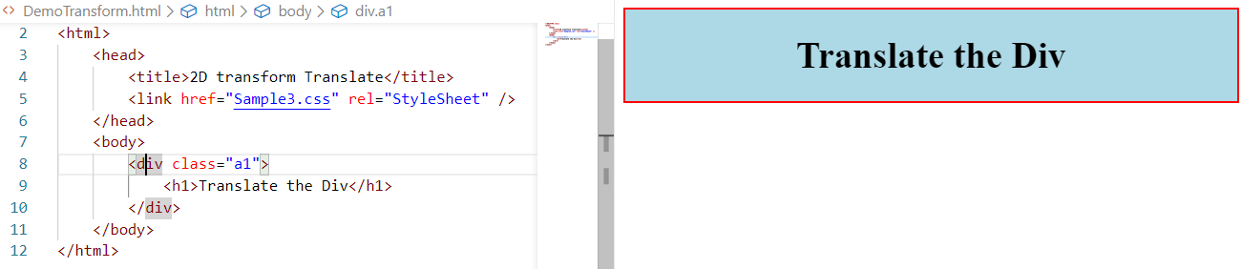

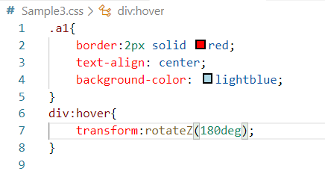

**Applying on Two Different div’s by using ID**

